**Project Report Templates**

**1. Introduction :**

**1.1Overview   
 Businesscards** are [cards](https://en.wikipedia.org/wiki/Card_stock) bearingbusiness [information](https://en.wikipedia.org/wiki/Information) about a [company](https://en.wikipedia.org/wiki/Company) or [individual](https://en.wikipedia.org/wiki/Individual). They are shared during formal introductions as a convenience and a memory aid. A business card typically includes the giver's name, [company](https://en.wikipedia.org/wiki/Types_of_companies) or business affiliation (usually with a [logo](https://en.wikipedia.org/wiki/Logo)) and contact information such as [street addresses](https://en.wikipedia.org/wiki/Address_(geography)), [telephone number](https://en.wikipedia.org/wiki/Telephone_number), [fax](https://en.wikipedia.org/wiki/Fax) number, [e-mail](https://en.wikipedia.org/wiki/E-mail) addresses and [website](https://en.wikipedia.org/wiki/Website). Before the advent of electronic communication, business cards also included [telex](https://en.wikipedia.org/wiki/Teletypewriter_message) details. Now they may include social media addresses such as [Facebook](https://en.wikipedia.org/wiki/Facebook), [LinkedIn](https://en.wikipedia.org/wiki/LinkedIn) and [Twitter](https://en.wikipedia.org/wiki/Twitter). Traditionally, many cards were simple black text on white stock, and the distinctive look and feel of cards printed from an engraved plate was a desirable sign of professionalism. In the late 20th century, technological advances drove changes in style, and today a professional business card will often include one or more aspects of striking visual design.

**1.2 Purpose :**

A business card is a highly personal form of marketing, and does exactly what you need it to. Business cards serve the key purpose of marketing your business and getting your key contact information into your client's hands… all in a matter of seconds. Fundamental to the value of the business card, is its portability. A good business card creates an image of professionalism, credibility and loyalty – all of which score high on a potential clients list of criterial when making a decision .

**2. Problem Definition & Design Thinking :**

**2.1 Empathy Map :**

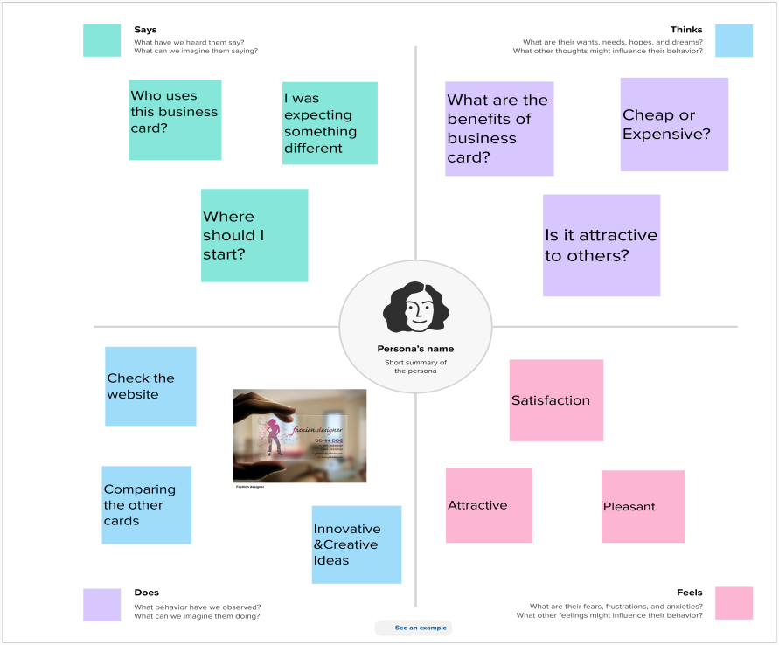

**2.2 Ideation & Brainstorming Map:**

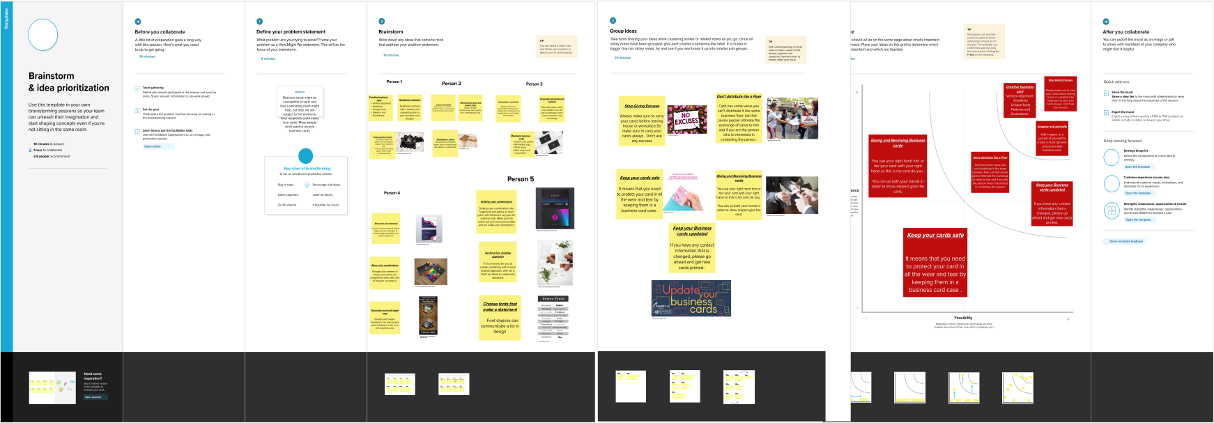

**3. Result :**

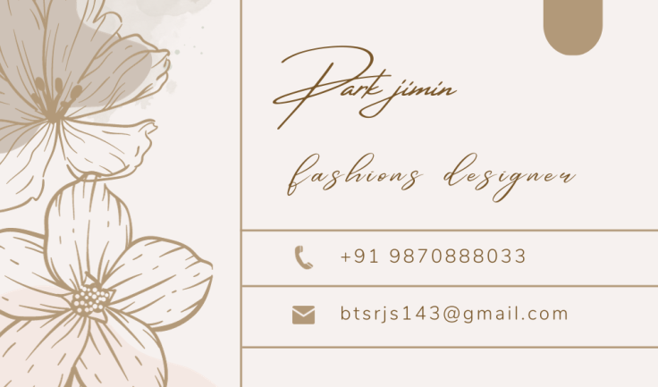

**4. Advantage & Disadvantage :**

**Advantages :**

* **More visible than an email**
* **Pocket sized to carry at all times**
* **Helps visually commit your brand to memory**
* **Easy to distribute and display**
* **Affordable way to promote your business.**

**Disadvantages :**

* **They lack a personal touch**
* **Not accessible to all**
* **Design limitations**
* **Esure a good design adaptation in devices**

**5. Application:**

* **F**ind local businesses related to your product or service and leaves cards at the counter
* Stick some of your business cards on college campus bulletin boards.
* Give your cards out to family and friends so they can give them away when they needed.
* Network with other local business owners and exchange business cards.
* Attend community events, network there and hand out your cards.

**6. Conclusion:**

In conclusion, digital business cards offer a great way to save time and money while also helping to protect the environment. With their convenience and cost-effectiveness, digital business cards are becoming increasingly popular among businesses and individuals.

**7. Future Scope :**

People are increasingly using digital networking channels, making digital business cards the cornerstone of modern-day marketing. While physical business cards are still relevant, incorporating digital business cards in your networking efforts is no longer an option.